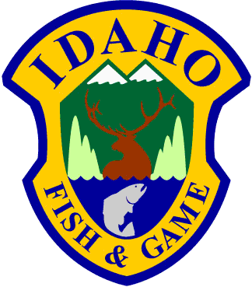
Idaho Department of Fish and Game
600 S Walnut / P.O. Box 25 C.L. "Butch" Otter / Governor
Boise, Idaho 83707 Virgil Moore / Director

May 20, 2018

Chris West, Director, Rocky Mountain Regional Office
National Fish and Wildlife Foundation
1133 Fifteenth St., N.W., Suite 1000
Washington, DC 2005

RE: Northern Rockies: Great Migrations and Crucial Corridors Program grant opportunity

Dear Mr. West:

This is an exit strategy letter, required to be submitted with our Grant Application Form. This letter is being submitted in advance of a National Fish and Wildlife Foundation grant being awarded. This is XXXX

There is no match required, except the 1:1 non-federal dollars being matched by our partner agency, the Idaho Transportation Department. All work will be done with existing staff or seasonal staff. There are no ongoing costs to the agency or the state as a result of this project. If the funding were to terminate, the project would continue with the reduced funding already in place. Please call David Smith at (208) 287-2740 if you have any questions.

Sincerely,

Virgil Moore
Director

VM:das
cc: Brad Compton, IDFG

