State of Idaho
DFM Tracking No.:_______________
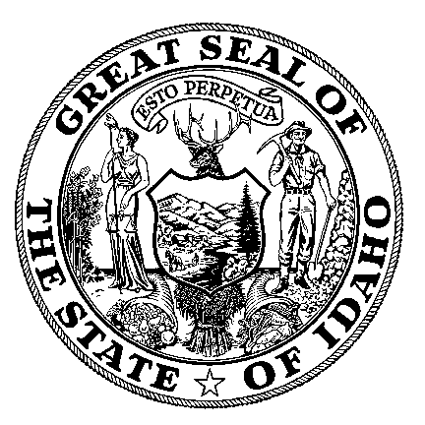
DIVISION OF FINANCIAL MANAGEMENT
Executive Office of the Governor

Grant Approval Form
Section 1 (To be completed by Agency)
Agency Name:  Idaho Department of Fish & Game |  |  | STARS Agency Code:  260 |  |  | Fax:  208-334-2114 |  | Date:8/23/2017
Contact Person:  David Smith  Project Leader:  Toby Boudreau | Title:Grants/Contracts Program Specialist  Title: Assistant Bureau Chief, Wildlife |  |  | Phone:  208-287-2740  Phone:  208-287-2756 |  | Email:  David.smith@idfg.idaho.gov  Email:  toby.boudreau@idfg.idaho.gov
Approving Official:  Michael Pearson | Title:  Bureau Chief, Admin |  |  | Phone:  208-287-2800 |  | Email:  Michael.pearson@idfg.idaho.gov
Section 2 (To be completed by Agency)
Type of Grant: X New Renewal |  | Federal CFDA: |  |  |  | DUNS #: 82-520-1510
Patient Protection and Affordable Care Act Funds (PPACA)? Yes X No
If yes, attach explanation of why you are requesting a waiver for these funds (Executive Order 2011-03).
Title of Grant: Northern Rockies: Great Migrations and Crucial Corridors Program
Targhee Pass Project, Protecting and Enhancing Wildlife Movement in a Critical Linkage Corridor
Brief Description (Including Source) and Long-Term Impact:
US Highway 20 and associated traffic in Island Park, Idaho, create a safety hazard for humans and wildlife and is a major impediment to wildlife movement in the High Divide region. In order to help protect and restore connectivity between the Greater Yellowstone Ecosystem and the High Divide for grizzly bears, wolverine, moose, elk, deer and pronghorn, the Idaho Department of Fish and Game and Idaho Transportation Departments are seeking funds to assist in the construction of wildlife crossing structures along a crucial stretch of this highway.

All work will be done with existing staff or seasonal staff. There are no ongoing costs to the agency or the state as a result of this project. If the funding were to terminate, the project would continue with the reduced funding already in place.

Note: Each agency must submit a letter signed by the agency director outlining an exit strategy in the event the grant expires.
Grant Application Due Date: 9/5/2017
Start Date: 7/1/2018 |  |  |  |  | Completion Date: 12/31/2021
Federal: $ |  |  |  |  | Other Sources Description:  National Fish and Wildlife Foundation (.org)
State: $
Local: $
Other Sources: $ 200,000
Total: $ 200,000 |  |  |  |  | Number of FTP:
Section 3 (DFM Use Only)
DFM Analyst Comments:

Date Received by DFM:

DFM Analyst Signature & Date: |  |  |  |  |  |  | Recommend:  Yes No
Governor’s Office Signature & Date: (PPACA Funds only) |  |  |  |  |  |  | Approval:  Yes No
DFM Administrator Signature & Date: |  |  |  |  |  |  | Approval:  Yes No
Return via email to: info@dfm.idaho.gov

