NORTHERN ROCKIES: GREAT MIGRATIONS AND CRUCIAL CORRIDORS PROGRAM RFP
PROJECT INFORMATION
Project Title: US Highway 20 Targhee Pass Project, Protecting and Enhancing Wildlife Movement in a Critical Linkage Corridor
Project Start Date: July 1, 2018
Project End Date: December 31, 2021 (need to caveat and/or request extended construction timeline as suggested by Chris West)
Description: Current traffic on US Highway 20 from Island Park, Idaho to the Montana state line creates both an impediment to wildlife movement and a safety hazard for drivers due to wildlife-vehicle collisions (WVCs). In order to help protect and restore connectivity between the Greater Yellowstone Ecosystem and the High Divide for wolverine, moose, elk, deer pronghorn and grizzly bears, the Idaho Department of Fish and Game and Idaho Transportation Departments are seeking funds to assist in the construction of wildlife crossing structures to coincide with highway improvements along this crucial stretch of this highway.
Abstract: US Highway 20 (US 20) from Island Park to the Idaho – Montana state line is a barrier to wildlife, with high rates of WVC’s creating, a safety hazard for motorists. Through an important partnership with Idaho Department of Fish and Game (IDFG), the Idaho Transportation Department (ITD) is designing US 20 highway elements to reduce wildlife-vehicle collisions and to maintain or improve wildlife connectivity as part of a highway improvement project on Targhee Pass. The project area traverses the Caribou-Targhee National Forest and private lands of the Yellowstone Plateau and is renowned as part of the Greater Yellowstone Ecosystem and for its associated megafauna and fisheries. Crossing structures for mule deer, elk, moose, pronghorn, black bear, grizzly bear and wolverine are proposed to be incorporated into the project by ITD and IDFG to improve wildlife connectivity and driver safety. Current allocation of project funding is sufficient to provide for construction of at least one crossing structure, two miles of wildlife fence and two culvert replacements to allow fish passage. However, recommendations of an independent contractor (Cramer 2016) and IDFG professional staff have identified installation of three wildlife overpasses, four miles of wildlife fence and accompanying access gates, cattle guards and fence end treatments and culvert replacements to provide for wildlife connectivity. This effort will reduce large mammal-vehicle collisions by 80-100% and increase landscape connectivity for all species. Longer-term plans to protect wildlife connectivity along the entire US 20 Corridor in Island Park (~50 miles of highway) and elsewhere in the west will be informed by this precedent-setting project.
Requested Amount: $200,000
PROJECT LOCATION
Project Location Country: North America — United States
Project Location State/Province: Idaho Montana
Project Location US Congressional District: Idaho Congressional District 2
Project Location Description: This project will occur in Fremont County, Idaho just outside the city limits of Island Park. Construction will occur on the US Highway 20 corridor between the junction with State Highway 87 and the Montana State line (mile markers 401.5 – 406.3).
MAPS
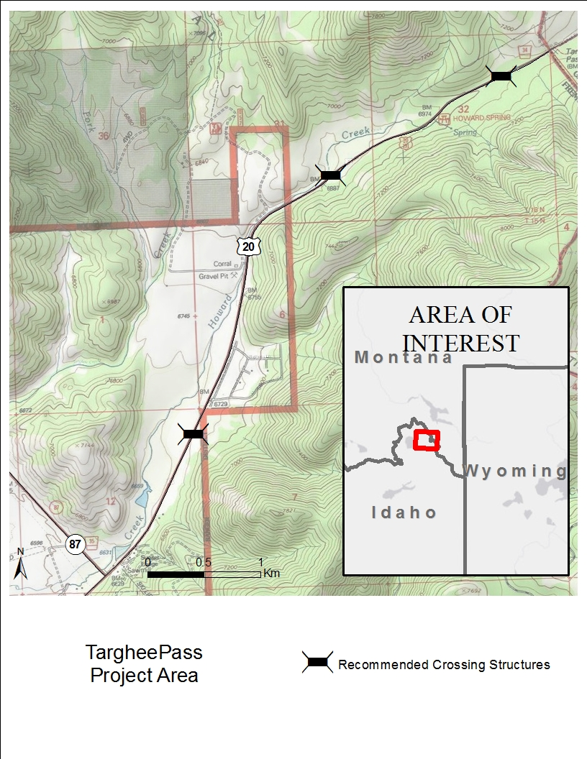
Figure 1. Targhee Pass Project Area location with locations of wildlife overpasses recommended by Idaho Department of Fish and Game.

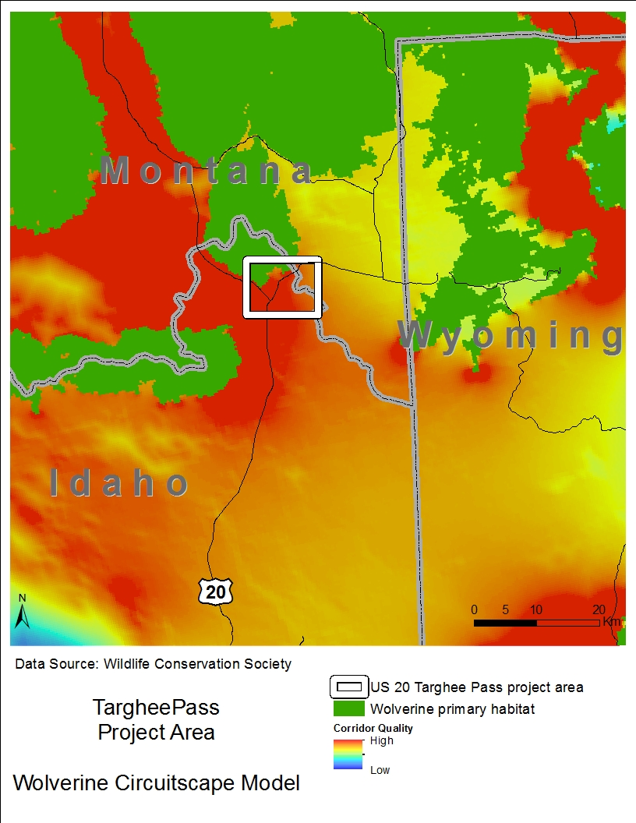
Figure 2. Wolverine Circuitscape corridor analysis shows predicted probability of use during dispersal events. Hotter colors have a higher probability of use. Green areas are wolverine primary habitat. Along US 20 in the Targhee Pass project area, primary habitat and high predicted dispersal habitat meet (Inman 2013).
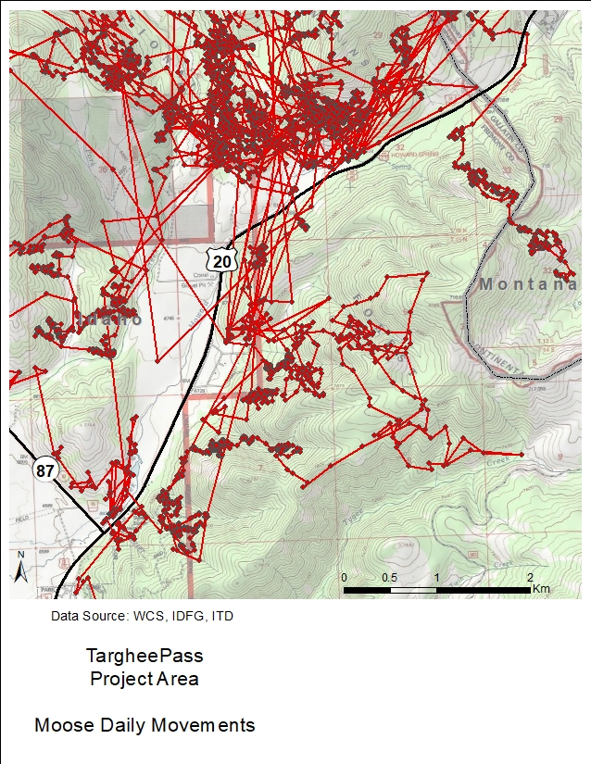
Figure 3. Annual movements of a radio-collared female non-migratory moose along US 20 in the Targhee Pass project area, 2011-2012. Location data collection intervals varied from twice daily to twice per hour, depending on time of year. Movement path was created using ArcGIS Points to Line tool. On Targhee Pass project area, data suggest this moose avoided crossing US 20 in key areas (Andreasen et al. 2014); however, moose movements still present a WVC risk to motorists on Targhee Pass; this moose crossed US 20 on the Targhee Pass project area at least 15 times.
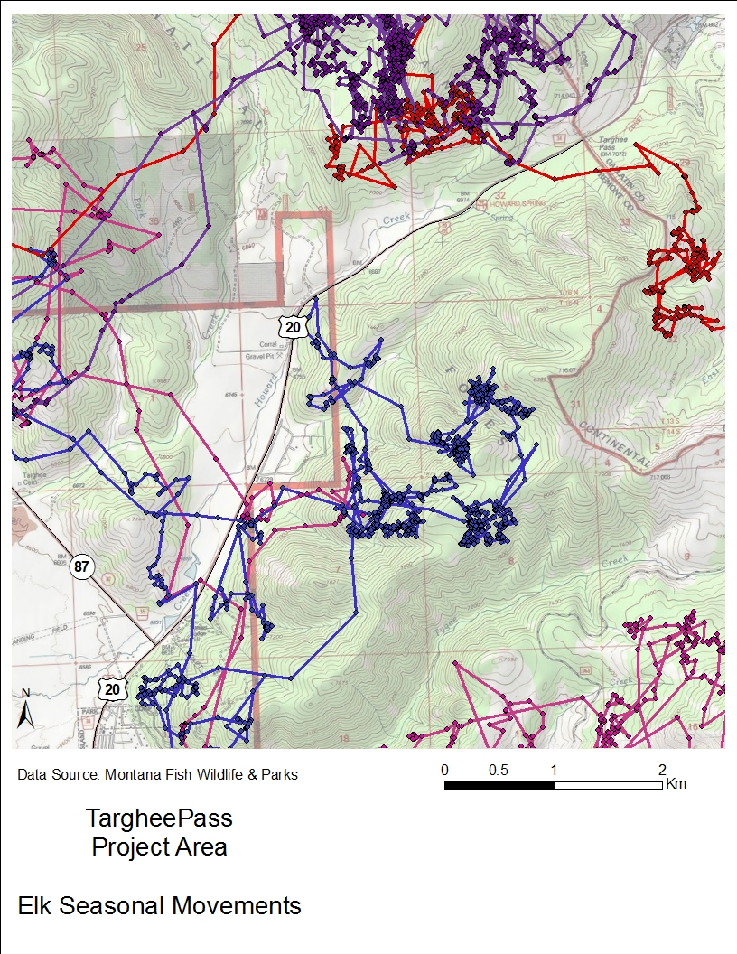
Figure 4. Migratory movements of radio-collared female elk along US 20 in the Targhee Pass project area, 2005-2007. Locations were collected every 30 minutes. Movement paths were created using ArcGIS Points to Line tool. Individual animals have different colored paths. Elk movements present a WVC risk to motorists in some areas where they cross the highway; in other areas, these data suggest elk avoid certain parts of US 20 (MFWP).
UPLOADS
Full Proposal Narrative: The US Highway 20 (US 20) Corridor in Island Park, Idaho is a critical Wildlife Linkage between the Greater Yellowstone Ecosystem and the High Divide Region of the Northern Rockies. It is also a major travel route for visitors to Island Park, West Yellowstone, Yellowstone National Park, the Madison Valley of Montana and Teton Valley, Idaho. A major freight corridor runs directly along this route bringing high-levels of heavy semi-truck traffic to the area (e.g., half of all produce freight from southern California travels US 20 through Island Park; Ben Burke, Traffic Engineer, ITD, personal communication). Along this two-lane highway, 441 vehicle crashes occurred over a five-year period and wildlife-vehicle collisions (WVCs) are the second most reported type of accident, accounting for 10% of recorded vehicle crashes (US 20 Corridor Plan). In the farthest north stretch of US 20 in Idaho, 23% of all crashes involve wildlife; 6% of these WVCs result in human injury. This four-mile stretch of road—the Targhee Pass project area (Fig. 1)—has led to many large mammal-vehicle collisions, including those resulting in mortality to mule deer, elk, moose, grizzly bear and bison. Small culverts under and alongside the highway block fish passage to the upper reaches of Howard Creek, a major tributary to Henry’s Lake.
Targhee Pass is a critical linkage for dispersing carnivores as their North American ranges expand. Grizzly bear and wolverine have both been documented traveling through this area and movement models from these species show that this narrow connection on the edge of the Greater Yellowstone Ecosystem is a priority area to protect for connectivity to the High Divide (Fig. 2; Schwarz et al. 2010, Inman 2013). Migratory elk, mule deer and pronghorn move across US 20 on Targhee Pass to reach winter range in the Madison Valley, as shown by Montana Fish Wildlife & Parks and IDFG GPS radio-collar and observational data. Non-migratory moose live year-round in this area, crossing the highway throughout the year as part of their daily movements (Andreasen et al. 2014). GPS radio-collar data from moose and elk show that these large ungulates not only pose a safety hazard to motorists but also suggest that key sections of Targhee Pass are impermeable to these animals (Figs. 3 & 4). Where these animals cross the road, they are vulnerable to WVCs. Where these animals are not able to cross the road, the resulting reduction in access to forage, mates, seasonal ranges, and breeding grounds can compromise individual and population fitness of the these important big game herds that travel in and out of Yellowstone National Park and the Island Park Caldera (Frid & Dill 2002, Gavin and Komers 2007).
This area is renowned for its native Yellowstone cutthroat trout (YCT) fishery. Howard Creek flows adjacent to and crosses under US 20 along Targhee Pass. It provides spawning habitat for YCT up to the lower impassable culvert, under Targhee Creek Trailhead road. Previous work to protect YCT in the area has included miles of bank restoration along Henry’s Lake and tributary streams as well as the replacement of 8 culverts and a bridge on State Highway 87 at the lower reach of Howard Creek. Installation of larger, bottomless culverts on Targhee Pass will build on the work done in the past and open the upper reaches of Howard Creek for YCT spawning and rearing.
The state agencies responsible for human safety and transportation (ITD) and the protection, preservation and perpetuation of wildlife (IDFG) are working together to reduce WVCs and protect and improve connectivity for wildlife in an unprecedented relationship, directed by a Cooperative Agreement (Smith 2017). This agreement guides the initial efforts of these sister agencies towards improving US 20 by increasing driver safety and maintaining and enhancing wildlife connectivity on the US 20 Corridor through Island Park, beginning with the Targhee Pass project. The Targhee Pass project will conserve and improve connection to critical habitat, ensuring safe movement routes for wildlife and safe driving for US 20 drivers. o The efforts on Targhee Pass and the US 20 Corridor will serve as a model for how the agencies’ missions can build both Idaho’s transportation system and sustainable management of Idaho’s wildlife. Best management practices—including the refinement of the agencies efficiently and effectively working in tandem, identifying wildlife needs along roads, creating recommendations that will improve wildlife connectivity and building highway design elements for wildlife—will be developed and documented during this project and applied to other projects in Idaho and adjacent states. Successes and lessons learned will be shared at local community events and state and national conferences and meetings, providing ideas and guidelines for other agencies and groups interested in improving roads for wildlife.
In support of this project, the Federal Highway Administration has committed $19,300,000, reserving approximately 10% of these monies to build highway design elements that will reduce WVCs and vastly improve connectivity for wildlife. IDFG is committed to provide expertise in wildlife ecology for the project, including information about the current effects of US 20 and proposed road improvements involving: 1) increasing the highway shoulder width to eight feet, 2) resurfacing and stabilizing the road, 3) building a climbing lane and turn lanes, and 4) straightening a curve to improve sight distance.
The Targhee Pass project is currently in scoping process as part of the Environmental Assessment. A complete analysis of the effects and alternatives of the project will be completed in summer 2018 and a final alternative for the project will presented at that time. Engineering and construction on the project will start in 2021. Under the recommendation of IDFG and Cramer (2016), multiple wildlife crossing structures and associated barrier fences are proposed to improve the effects of US 20 on wildlife connectivity and driver safety (Fig. 1). If implemented, the overpass crossing structures will provide safe passage for moose, elk, deer, pronghorn, black bears, grizzly bears and wolverine as well as many other species. Culvert improvements will allow passage for YCT to stream reaches on Howard Creek that the fish cannot currently access.
Proposed wildlife overpasses include three 50-meter wide overpasses with dirt berms on the side to reduce highway sounds (Clevenger & Huijser 2011). Culverts will be 3+ meters wide to reach at least 150% bankfull width, allowing movement of small mammals, reptiles and amphibians in addition to fish. In order to retain human access for hunting, fishing and hiking, swing gates will be installed in the 2.4 – 3.0 meter-high fence. Double wide cattle guards, electrified mats (Huijser et al. 2015) and fence end treatments will be assessed for vehicle access that limits wildlife passage at side roads and fence ends.
After Targhee Pass project is in the design phase, ITD and IDFG will turn their efforts to the entire US 20 Corridor where ITD has multiple road improvement projects planned. These projects provide opportunities to reduce the impact of the road on wildlife by increasing the efficiency and cost-effectiveness of combining road improvements with wildlife mitigation efforts. The work on Targhee Pass will help inform the landscape-scale picture for the Island Park Caldera in terms of wildlife and roads and can help direct further projects to keep the ecosystem whole. Funding from the National Fish and Wildlife Foundation will round out the needs to allow ITD and IDFG to create the first in the series of wildlife overpasses.
Past Successes [Ask Chris West what NFWF is looking for here- do they want partner bios?]
Literature Cited
Andreasen, A. M., R. G. Seidler, S. Roberts, H. Miyasaki, P. Zager, M. Hurley, S. Ber-gen, D. Meints, P. Atwood, J. Berger, T. Cramer, and Jon P. Beckmann. 2014. US 20, Island Park wildlife collision study: an examination of road ecology in the Island Park Caldera, elk and moose migrations across US Highway 20— Final Report. Wildlife Conservation Society, Idaho Transportation Department, and Idaho Department of Fish and Game.
Clevenger, A.P. and M.P. Huijser. 2011. Wildlife Crossing Structure Handbook Design and Evaluation in North America. FHWA Report.
Cramer, P.C. 2016. Safety solutions for wildlife-vehicle collisions on Idaho’s US 20 and SH 87. Research Report for Idaho Transportation Department.
Frid, A. and L. Dill. 2002. Human-caused disturbance stimuli as a form of predation risk. Conservation Ecology 6.
Gavin, S.D. and P.E. Komers. 2006. Do pronghorn (Antilocapra americana) perceive roads as a predation risk? Canadian Journal of Zoology 84: 1775-1780.
Huijser, M.P., A.V. Kociolek, T.D.H. Allen, and P. McGowen. 2015. Construction guidelines for wildlife fencing and associated escape and lateral access control measures. Report: American Association of State Highway and Transportation Officials (AASHTO).
Inman, R.M. 2013. Wolverine ecology and conservation in the western United States. Doctoral Thesis. Swedish University of Agricultural Sciences.
Schwarz, C.C., M.A. Haroldson and G.C. White. 2010. Hazards affecting grizzly bear survival in the Greater Yellowstone Ecosystem. The Journal of Wildlife Management 74: 654-667.
Smith, C. 2017. Idaho and WMI cooperate to reduce wildlife-vehicle collisions and improve wildlife connectivity. Wildlife Management Institute News Bulletin 71.

PROJECT METRICS
Fish passage improvements: Two fish passage barriers will be rectified, resulting in approximately one mile of stream opened. The barriers are small culverts which don’t allow for YCT passage because they are too small, too long and provide no recovery zones for fish moving upstream. New, bottomless culverts will allow fish, small mammal, amphibian and reptile passage.
BMP implementation for road improvements: Four miles of US 20 will be modified to allow safe movement of wildlife over crossing structures between barrier fencing. Crossing structures will be monitored for wildlife use after construction. Wildlife-vehicle crashes (WVCs) will be compared before and after road improvements are made. An 80-100% reduction in WVCs are expected (Clevenger & Huijser 2011).
BUDGET
Need figures from ITD to flesh this out. Where do I show the final $668,955 covered? This will be best as a complete budget (meeting all needs for 1 crossing structure, 2 culverts, and 3 miles of fence).

Item | Cost/unit | Units | Total Cost | NFWF | ITD Match | Balance Needed  (ITD? FLAP?)
Overpass | $ 1,854,395 | 1 | $ 1,854,395 | $200,000 | $985,440 | <--(% state/federal)
Fish passage culvert | $ 5,000 | 2 | $ 10,000 |  | $10,000
Fencing (w all assoc. access)/mile | $ 311,520 | 3 | $ 934,560 |  | $934,560
Total |  |  | $ 2,798,955 | $200,000 | $1,930,000 | $ 668,955

MATCHING CONTRIBUTIONS
ITD $200,000 non-federal match
PERMITS and APPROVALS
CTNF- Obtain letter of support from Liz.
NGO- Obtain letter of support from TNC.

