NORTHERN ROCKIES: GREAT MIGRATIONS AND CRUCIAL CORRIDORS PROGRAM RFP
PROJECT INFORMATION
Project Title: Highway 20 Targhee Pass Project, Protecting and Enhancing Wildlife Movement in a Critical Linkage Corridor
Project Start Date: July 1, 2018
Project End Date: December 31, 2021 (need to caveat and/or request extended construction timeline as suggested by Chris West)
Description: Current traffic on US Highway 20 from Island Park, Idaho to the state line, creates both a movement barrier to wildlife and asafety hazard for drivers due to wildlife-vehicle collisions (WVC) with wolverine, antelope, elk, deer, bear, bison, and moose. Current proposals to improve US 20 to improve traffic flow will increase both the speed and volume of traffic and increase US 20 barrier and safety without attention to providing for wildlife connectivity through construction of crossing structures. The Idaho Department of Fish and Game and Idaho Transportation Departments are seeking funds to assist in the construction of wildlife crossing structures to coincide with highway improvements along this crucial stretch of this highway.
Abstract: US Highway 20 (US 20) from Island Park to the Idaho – Montana state lineis a barrier to wildlife, with high rates of WVC’s creating , a safety hazard for motorists. Through an important partnership with Idaho Department of Fish and Game (IDFG), the Idaho Transportation Department (ITD) is designing US 20 highway elements to reduce wildlife-vehicle collisions and maintain or improve wildlife connectivity as part of a highway improvement project on Targhee Pass. The project area traverses the Caribou-Targhee National Forest and private lands of the Yellowstone Plateau and is renowned as part of the Yellowstone Ecosystem and its associated megafauna and fisheries. Crossing structures for use by mule deer, elk, moose, pronghorn, black bear, grizzly bear and wolverine are being incorporated into US 20 design by ITD and IDFG to improve wildlife connectivity and driver safety. Current allocation of project funding provides for the construction of one crossing structure, two miles of wildlife fence and two culverts allowing fish passage. However, based on reccomendations of an independent contractor (Cramer 2016) and IDFG professional staff, installation of three wildlife overpasses, four miles of wildlife fence and accompanying access gates, cattle guards and fence end treatments are necessary to provide for adequate wildlife connectivity for the above species. This effort will reduce large mammal-vehicle collisions by 80-100% and increase landscape permeability for all species. In addition, longer-term plans to protect wildlife connectivity along the entire US 20 Corridor in Island Park (~50 miles of highway) and elsewhere in the west will be informed by this precedent-setting project.
Requested Amount: $200,000
PROJECT LOCATION
Project Location Country: North America — United States
Project Location State/Province: Idaho Montana
Project Location US Congressional District: Idaho Congressional District 2
Project Location Description: This project will occur in Fremont County, Idaho just outside the city limits of Island Park. Construction will occur on the US Highway 20 corridor between the junction with State Highway 87 and the Montana State line (mile markers 401.5 – 406.3).
MAPS
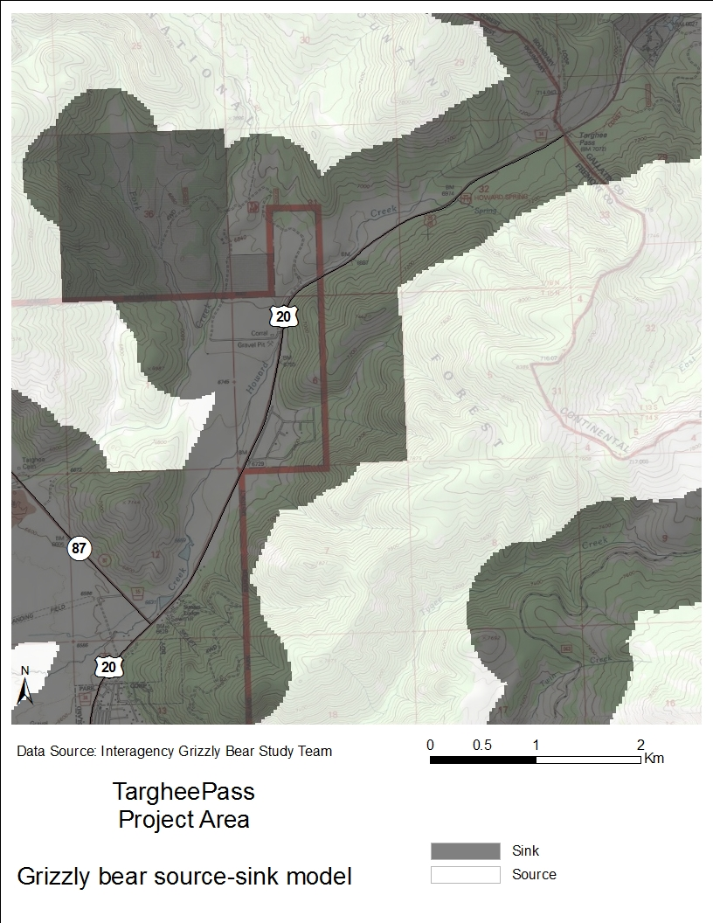
Figure 1. Grizzly bear source-sink model. Female grizzly bear survival rate for source areas (no color) >=0.91; survival rate for sink areas (in gray) <0.91. The entire US 20 corridor on the Targhee Pass project area is predicted as a sink area for grizzly bears (Schwarz et al. 2010).
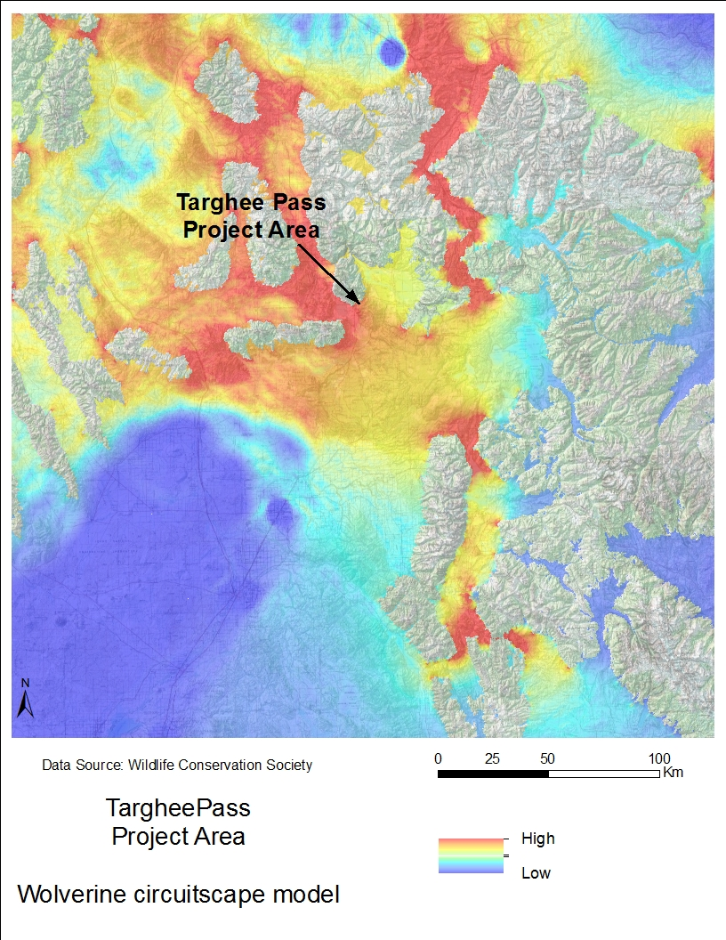
Figure 2. Wolverine Circuitscape corridor analysis shows predicted probability of use during dispersal events. Hotter colors have a higher probability of use. Areas with no color are wolverine source habitat. Along US 20 in the Targhee Pass project area, source habitat and high predicted dispersal habitat meet (Inman 2013).
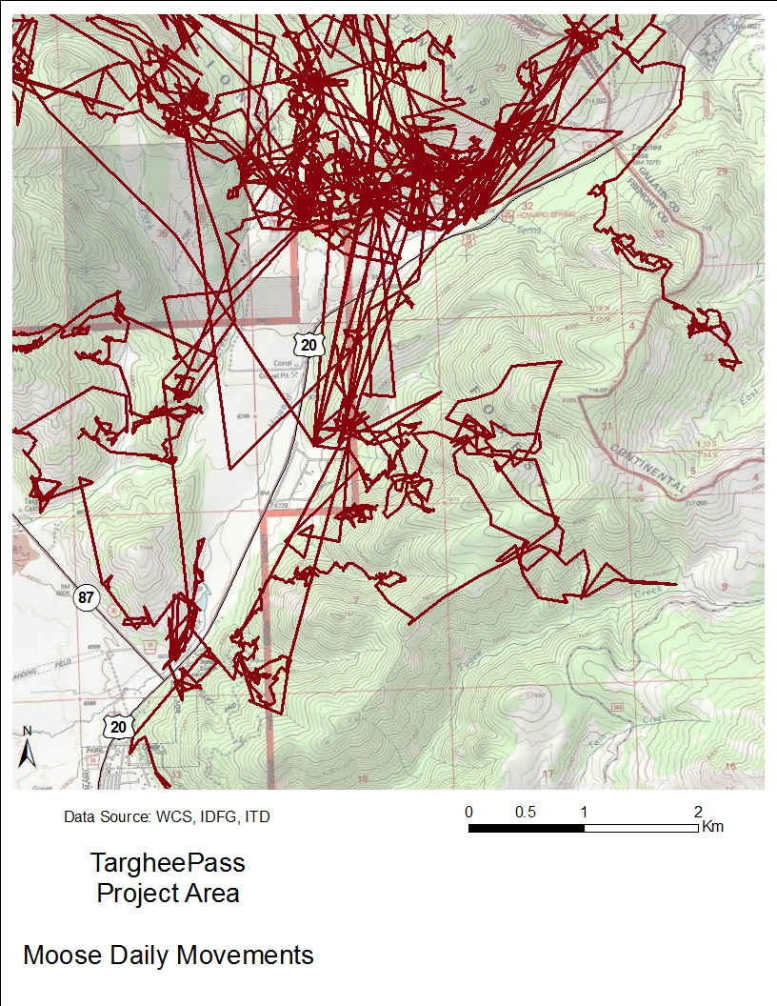
Figure 3. Annual movements of a radio-collared female non-migratory moose along US 20 in the Targhee Pass project area, 2011-2012. Location data collection intervals varied from twice daily to twice per hour, depending on time of year. Movement path was created using ArcGIS Points to Line tool. Movements suggest avoidance of certain parts of US 20 (Andreasen et al. 2014).
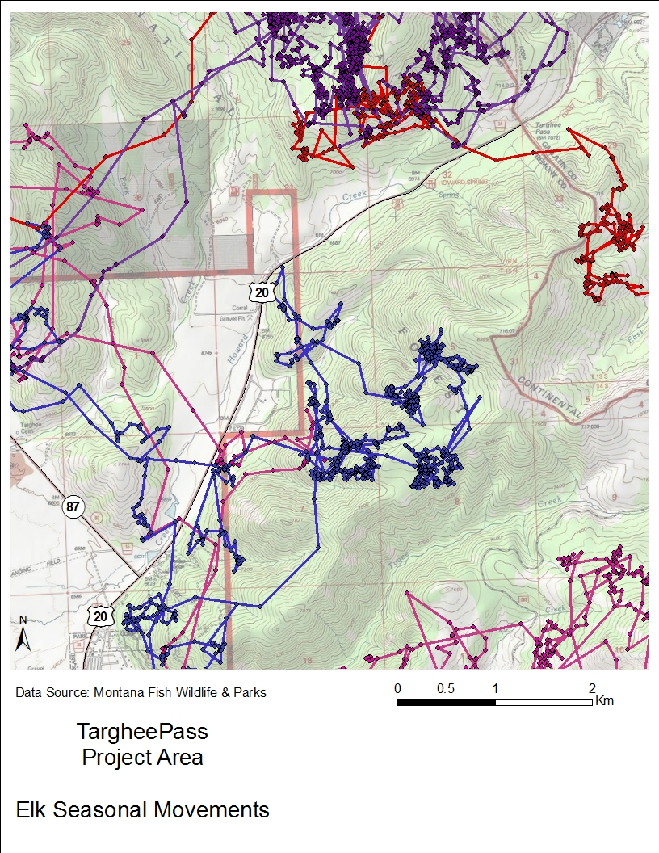
Figure 4. Migratory movements of radio-collared female elk along US 20 in the Targhee Pass project area, 2005-2007. Locations were collected every 30 minutes. Movement paths were created using ArcGIS Points to Line tool. Movements suggest avoidance of certain parts of US 20 (MFWP).
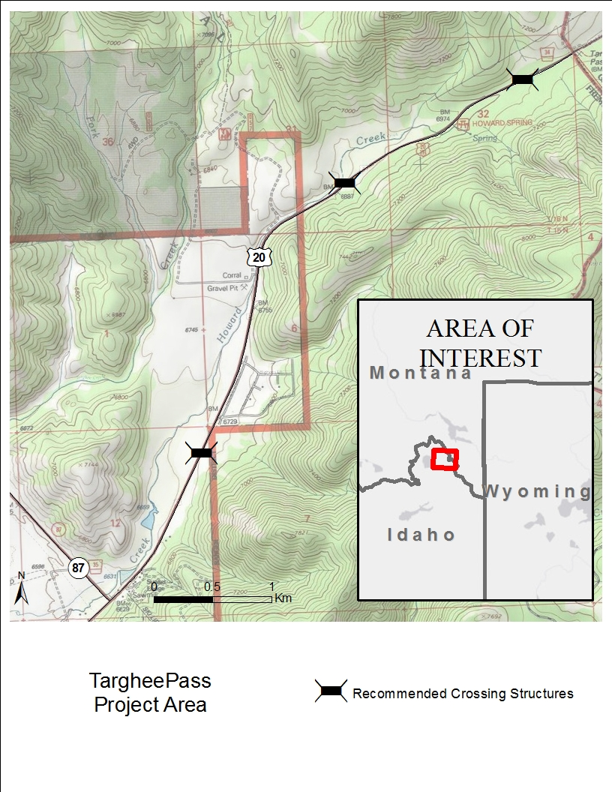
Figure 5. Locations of wildlife overpasses recommended by Idaho Department of Fish and Game.
UPLOADS
Not sure if hyperlinks will upload, but for now am using them. Full Proposal Narrative: The US Highway 20 (US 20) Corridor in Island Park, Idaho is a critical Wildlife Linkage between the Greater Yellowstone Ecosystem and the High Divide Region of the Northern Rockies. It is also a major travel route for visitors to Island Park, West Yellowstone, Yellowstone National Park, the Madison Valley of Montana and Teton Valley, Idaho. A major freight corridor runs directly along this route bringing high-levels of heavy semi-truck traffic to the area (e.g., half of all produce freight from southern California travels US 20 through Island Park; Ben Burke, Traffic Engineer, ITD, personal communication). Along this two-lane highway, 441 vehicle crashes occurred over a five-year period and wildlife-vehicle collisions (WVCs) are the second most reported type of accident, accounting for 10% of recorded vehicle crashes (US 20 Corridor Plan). In the farthest north stretch of US 20 in Idaho, 23% of all crashes involve wildlife; 6% of these WVCs result in human injury. This four-mile stretch of road—the Targhee Pass project area—has led to many large mammal-vehicle collisions, including those resulting in mortality to mule deer, elk, moose, grizzly bear and bison.
Targhee Pass is a critical linkage for dispersing carnivores as their North American ranges expand. Grizzly bear and wolverine have both been documented traveling through this area and models show that this narrow connection between critical habitat patches is a priority area for protection (Figs. 1 & 2; Schwarz et al. 2010, Inman 2013). Migratory elk, mule deer and pronghorn move across US 20 on Targhee Pass to reach winter range in the Madison Valley (Montana Fish Wildlife & Parks pers comm???). Non-migratory moose live year-round in this area, crossing the highway throughout the year as part of their daily movements (Andreasen et al. 2014). GPS radio-collar data from moose and elk suggest that key sections of Targhee Pass are impermeable to these animals (Figs. 3 & 4). The resulting reduction in access to forage, mates, and breeding grounds can compromise individual and population fitness of the majestic herds that travel in and out of Yellowstone National Park and the Island Park Caldera (Frid & Dill 2002, Gavin and Komers 2007).
.
The state agencies responsible for human safety and transportation (ITD) and the protection, preservation and perpetuation of wildlife (IDFG) are working together to reduce wildlife-vehicle collisions and correct the loss of landscape permeability for wildlife in an unprecedented relationship, directed by a Cooperative Agreement (Smith 2017). This agreement guides the initial efforts of these sister agencies towards maintaining and enhancing wildlife connectivity on the US 20 Corridor through Island Park, beginning with the Targhee Pass project. This project will conserve, and improve connection to this critical habitat, ensuring safe movement routes for wildlife and safe driving for US 20 drivers. Eventually, this relationship will broaden towards statewide roadway and wildlife projects and so The efforts on Targhee Pass and the US 20 Corridor will serve as a model for how to unite the agencies’ missions to protect humans and wildlife alike. Best management practices—including the refinement of the agencies efficiently and effectively working in tandem, identifying wildlife needs along roads, creating recommendations that will improve wildlife connectivity and building highway design elements for wildlife—will be developed and documented during this project and applied to other projects in Idaho and adjacent states. Successes and lessons learned will be shared at local community events and state and national conferences and meetings, providing ideas and guidelines for other agencies and groups interested in improving roads for wildlife.
In support of this project, the Federal Highway Administration has committed $19,300,000, reserving approximately 10% of these monies to build highway design elements that will reduce WVCs and while vastly improving the connectivity for wildlife. IDFG is committed to provide expertise in wildlife ecology for the project, including information about the current effects of US 20 and proposed road improvements including: 1) increasing the highway shoulder width to eight feet, 2) resurfacing and stabilizing the road, 3) building a climbing lane and turn lanes, and 4) straightening a curve to improve sight distance.
How to word this so it doesn’t seem like it might not happen? The Targhee Pass project is currently in scoping process as part of the Environmental Assessment. A complete analysis of the effects and alternatives of the project will be completed in summer 2018 and a final alternative for the project will presented at that time. Engineering and construction on the project will start in 2021. Under the recommendation of IDFG and Cramer (2016), multiple wildlife crossing structures and associated barrier fences are proposed to alleviate the effects of US 20 on wildlife connectivity and driver safety (Fig. 5). If implemented, the overpass crossing structures will provide for moose, elk, deer, pronghorn, black bears, grizzly bears and wolverine as well as many other species.
Proposed wildlife overpasses include three 50-meter wide overpasses with dirt berms on the side to reduce highway sounds (Clevenger & Huijser 2011). Culverts will be 3+ meters wide to reach at least 150% bankfull width, allowing movement of small mammals, reptiles and amphibians in addition to fish. In order to retain human access for hunting, fishing and hiking, swing gates will be installed in the 2.4 – 3.0 meter-high fence. Double wide cattle guards, electrified mats (Huijser et al. 2015) and fence end treatments will be assessed for vehicle access that limits wildlife passage at side roads and fence ends.
After Targhee Pass project is in the design phase, ITD and IDFG will turn their efforts to the entire US 20 Corridor where ITD has multiple road improvement projects planned. These projects provide opportunities to reduce the impact of the road on wildlife by increasing the efficiency and cost-effectiveness of combining road improvements with wildlife mitigation efforts. The work on Targhee Pass will help inform the landscape-scale picture for the Island Park Caldera in terms of wildlife and roads and can help direct further projects to keep the ecosystem whole. Funding from the National Fish and Wildlife Foundation will round out the needs to allow ITD and IDFG to create the first in the series of wildlife overpasses.
Past Successes [Ask Chris West what NFWF is looking for here- do they want partner bios?]
Literature Cited
Andreasen, A. M., R. G. Seidler, S. Roberts, H. Miyasaki, P. Zager, M. Hurley, S. Ber-gen, D. Meints, P. Atwood, J. Berger, T. Cramer, and Jon P. Beckmann. 2014. US 20, Island Park wildlife collision study: an examination of road ecology in the Island Park Caldera, elk and moose migrations across US Highway 20— Final Report. Wildlife Conservation Society, Idaho Transportation Department, and Idaho Department of Fish and Game.
Clevenger, A.P. and M.P. Huijser. 2011. Wildlife Crossing Structure Handbook Design and Evaluation in North America. FHWA Report.
Frid, A. and L. Dill. 2002. Human-caused disturbance stimuli as a form of predation risk. Conservation Ecology 6.
Gavin, S.D. and P.E. Komers. 2006. Do pronghorn (Antilocapra americana) perceive roads as a predation risk? Canadian Journal of Zoology 84: 1775-1780.
Huijser, M.P., A.V. Kociolek, T.D.H. Allen, and P. McGowen. 2015. Construction guidelines for wildlife fencing and associated escape and lateral access control measures. Report: American Association of State Highway and Transportation Officials (AASHTO).
Inman, R.M. 2013. Wolverine ecology and conservation in the western United States. Doctoral Thesis. Swedish University of Agricultural Sciences.
Schwarz, C.C., M.A. Haroldson and G.C. White. 2010. Hazards affecting grizzly bear survival in the Greater Yellowstone Ecosystem. The Journal of Wildlife Management 74: 654-667.
Smith, C. 2017. Idaho and WMI cooperate to reduce wildlife-vehicle collisions and improve wildlife connectivity. Wildlife Management Institute News Bulletin 71.

PROJECT METRICS
Fish passage improvements: Two fish passage barriers will be rectified, resulting in approximately one mile of stream opened. The barriers are small culverts which don’t allow for YCT passage because they are too small, too long and provide no recovery zones for fish moving upstream. New, bottomless culverts will allow fish, small mammal, amphibian and reptile passage.
BMP implementation for road improvements: Four miles of US 20 will be modified to allow safe movement of wildlife over crossing structures between barrier fencing. Crossing structures will be monitored for wildlife use after construction. Wildlife-vehicle crashes (WVCs) will be compared before and after road improvements are made. An 80-100% reduction in WVCs are expected (Clevenger & Huijser 2011).
BUDGET
Need figures from ITD to flesh this out. Where do I show the final $287,435 covered? IDFG? ITD? This will be best as a complete budget (meeting all needs for 1 crossing structure, 2 culverts, and 2 miles of fence).
Item | Cost/unit | Units | Total Cost | NFWF | ITD Match
Overpass | $ 1,854,395 | 1 | $ 1,854,395 | $200,000 | $1,366,960 | (% state/federal)
Fencing (w all assoc. access)/mile | $ 311,520 | 2 | $ 623,040 |  | $623,040
Total |  |  | $ 2,487,435 | $200,000 | $2,000,000

MATCHING CONTRIBUTIONS
ITD $200,000 non-federal match
PERMITS and APPROVALS
CTNF?
Also, letter of support from ITD, other?

